|  |
| --- |
|  |
| Online Toy Store |
|  |
| Project Report – CS 6314.001 |
| Sajid Siddiqui (SXS140731)  Kunal Tripathi (KXT142730)  Haripriyaa M (HUM160030) |

**Web programming languages**

Fall 2016

Online Toy Store

Project Report – CS 6314.001

# Overview

Toybox is an e-commerce website for an online toy store. The website has all the features that are expected in a modern e-commerce website viz. Product catalog, User Account Management, User Authentication, Cart functionality, Administrator Privileges to maintain product catalog, client and server side form validation, maintaining user information through tracking of sessions and cookies. The catalog contains toys classified on various categories.

# Assumptions

* The toys are not limited in number. They are available in our inventory till admin deletes it from the catalog.
* Admin can login and add, update items. Admin can also disable a product to limit it from displaying in the inventory.

# User Roles

# Guests:

* Guests have access to only the homepage and page containing the product information. They may view the products available and their details, but they will not be able to add these products to their cart and purchase them as a guest.
* Guests may also subscribe to receiving monthly deals in their inbox without having to create an account.

# Registered Users:

* Users may register using their email address. Email addresses are unique to each account. No two accounts may share the same email address.
* User passwords are hashed using a randomly generated 10-digit salt and the hashed value is stored in the database. A new salt is generated each time the user changes their password.
* The hashing is done using ‘sha1’ and ‘md5’ functions provided in PHP.
* Upon registering the users are mailed a confirmation code. The confirmation code is a randomly generated 10-digit code.
* On following the link provided in the email the account is verified and is authorized to purchase products from the account.
* Registered users are allowed provided access to the products pages with the now available option to add products and purchase them right then or anytime in the future.

# Administrator:

* Administrators have all the privilege of guest and registered users.
* Administrators may also add new products to the store database. This also involves the option to upload images for the new product.
* Administrators may update information about any existing products in the store database.
* They may also disable products thereby making them unavailable to registered and guest users.

# Database Design

## ../Documents/Courses/WPL/Project/Table%20Schema.png

# Technologies used

* Web Server: Apache
* Server-Side Scripting: PHP
* Backend: MySQL
* Client-Side Scripting: JavaScript, AJAX, JQuery
* Front-end: HTML, CSS, Bootstrap

# Screenshots

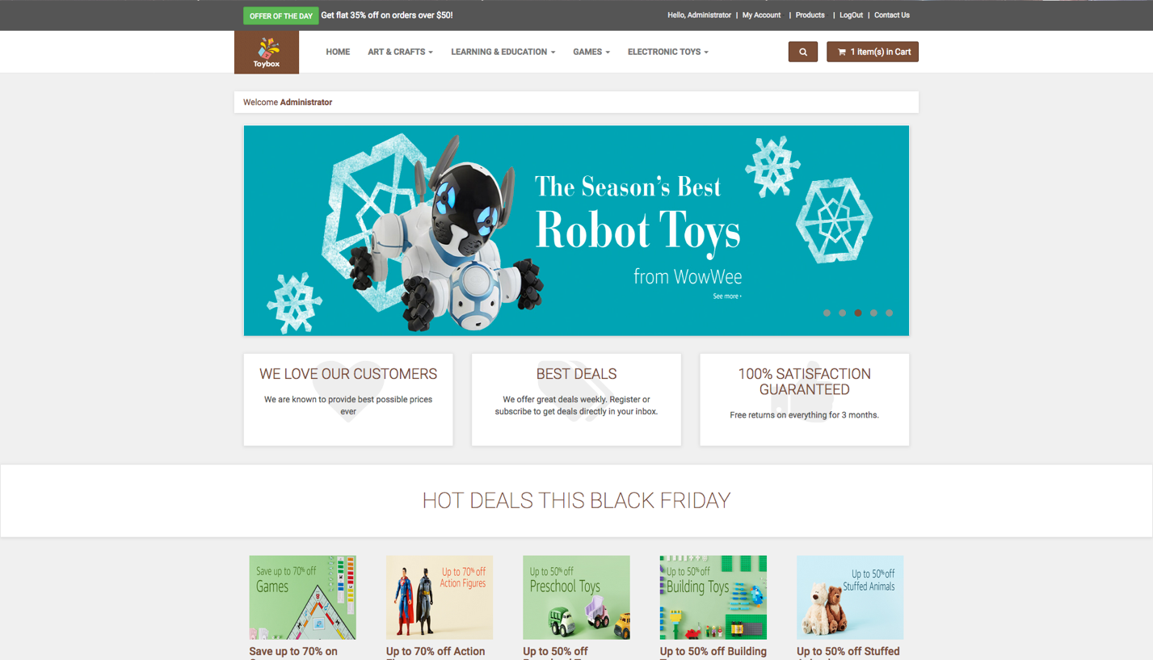

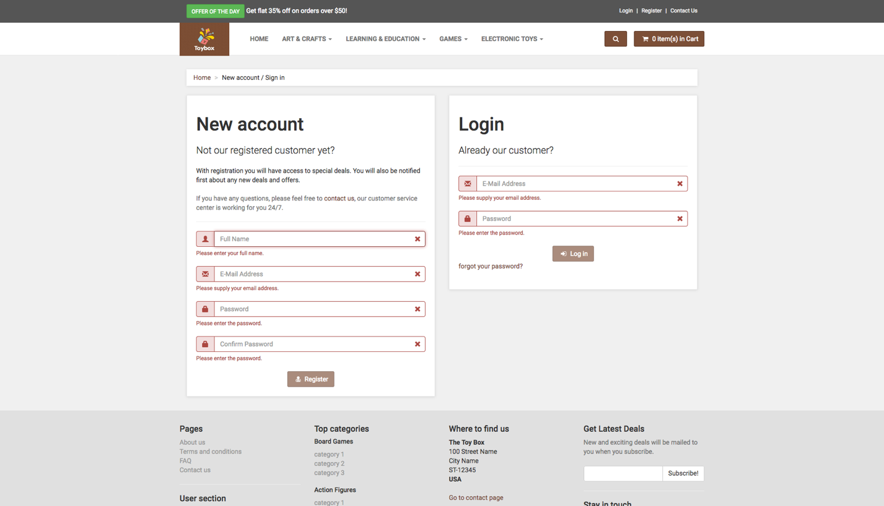

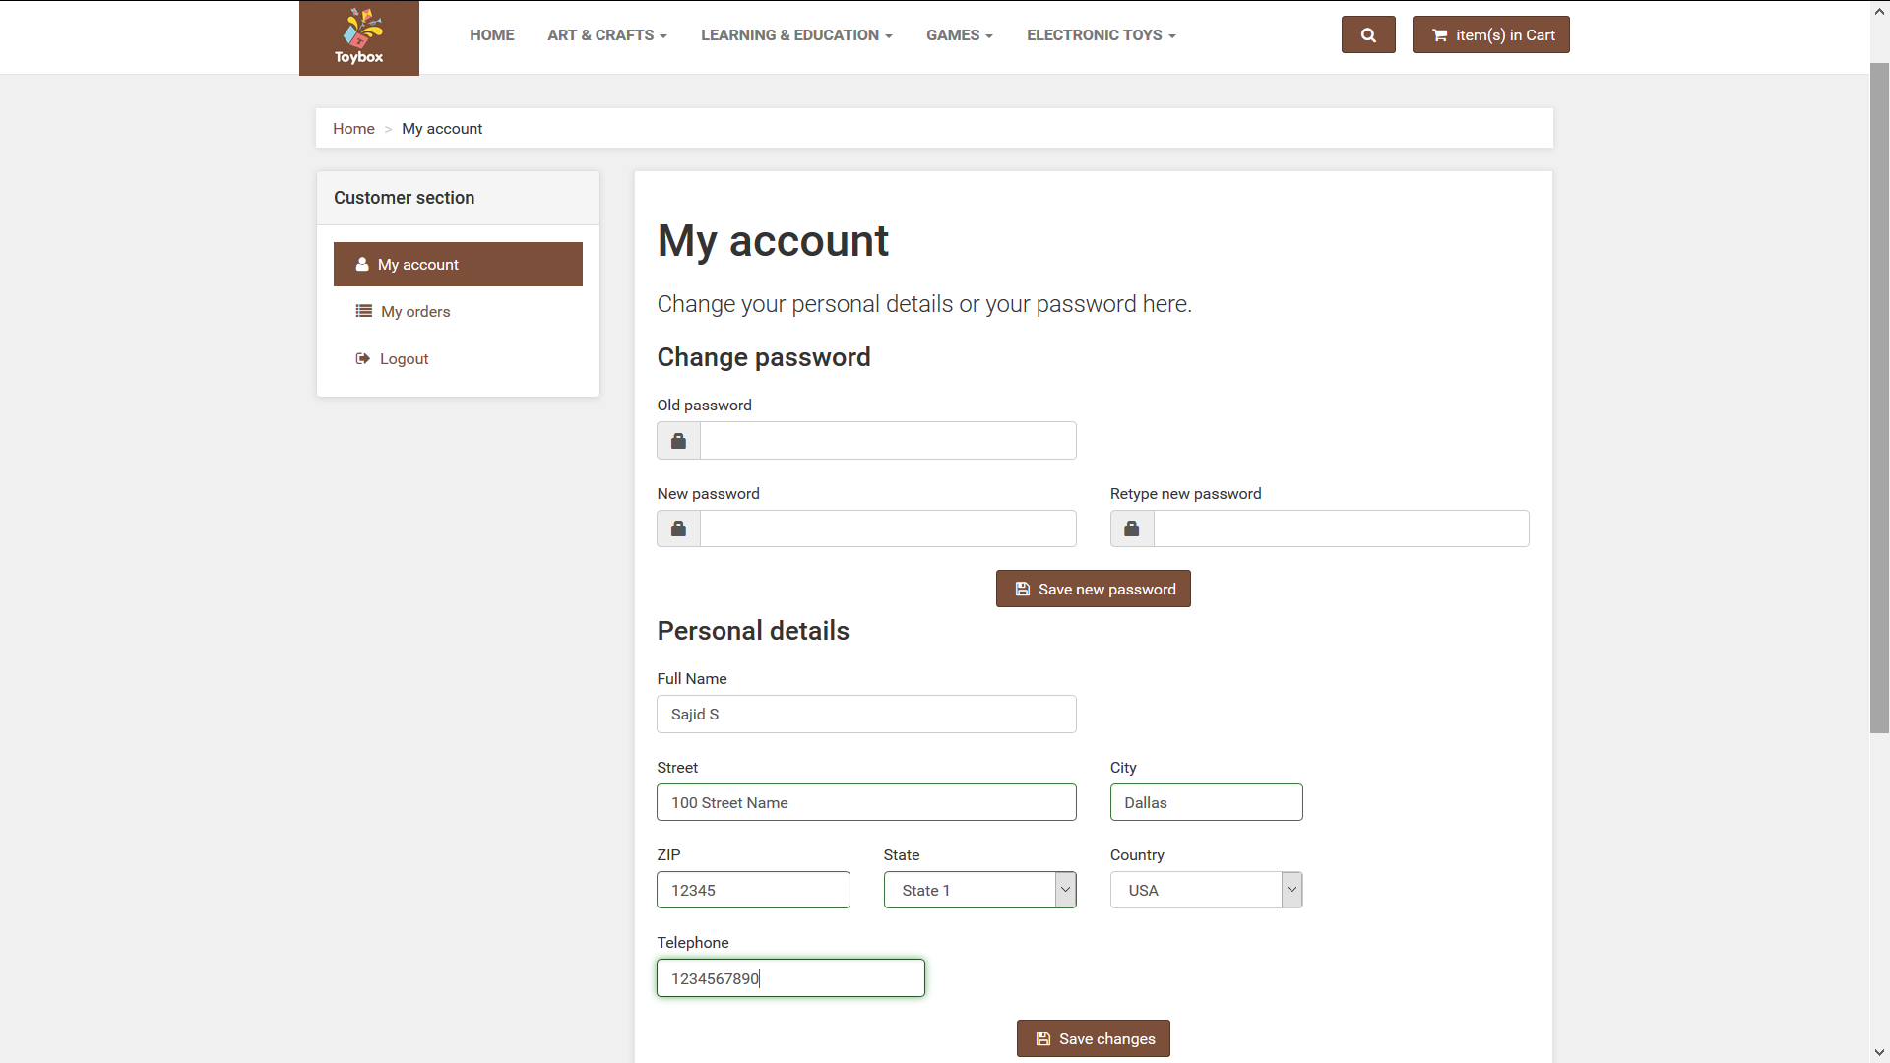

Add New Product Screen (Only for users with administrator privileges):

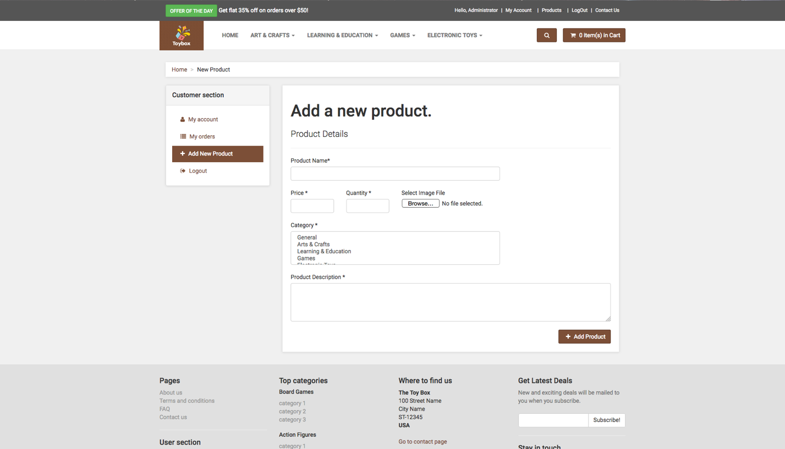

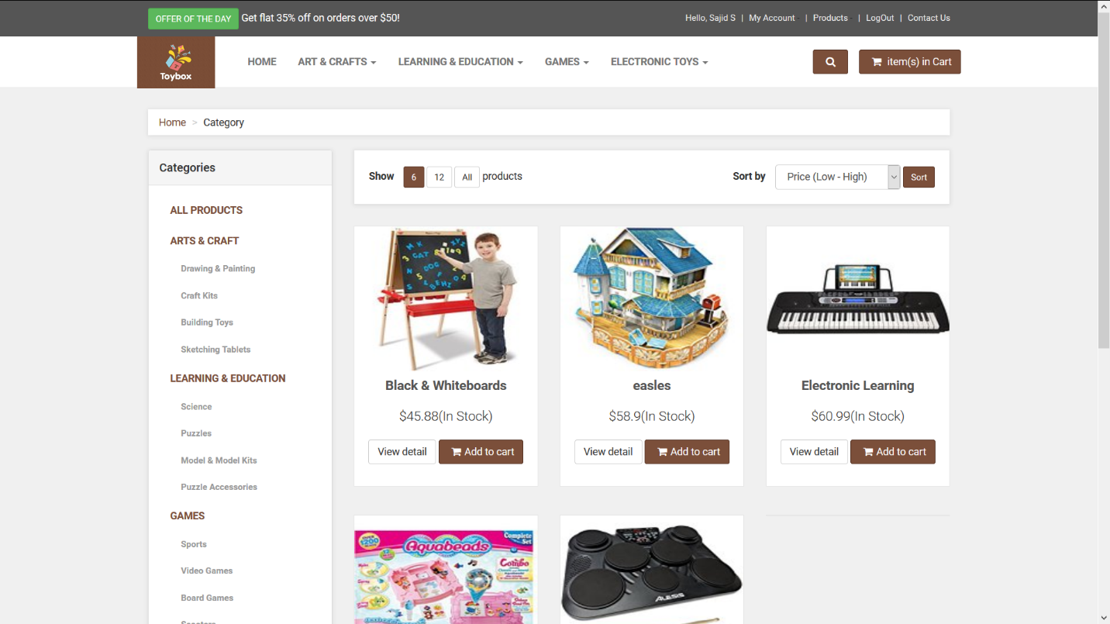

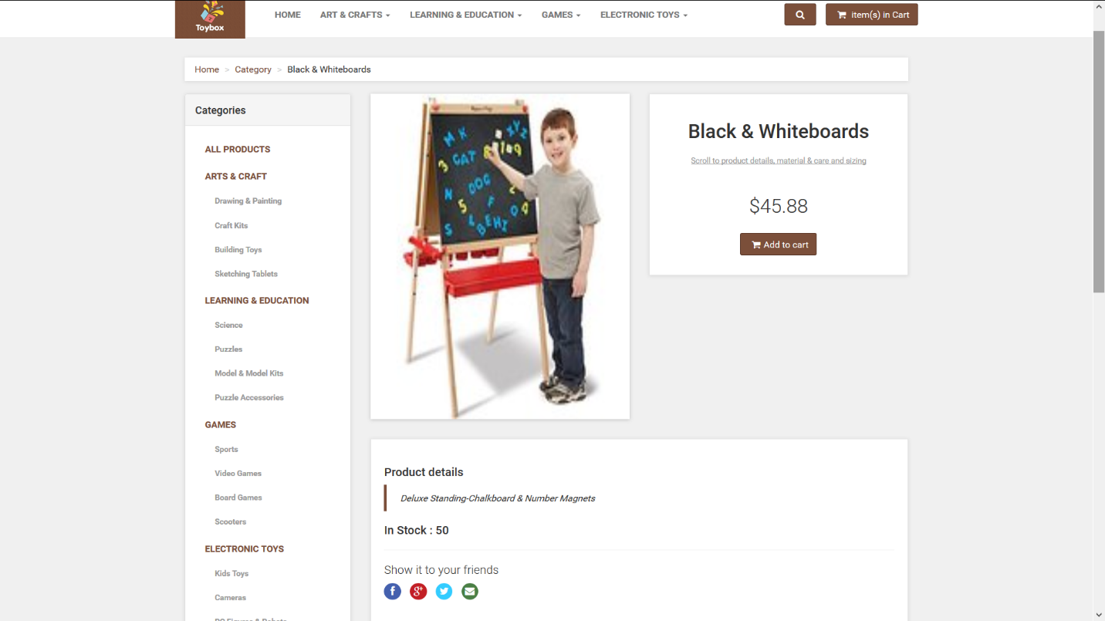

Update Product Screen (Only for users with administrator privileges):

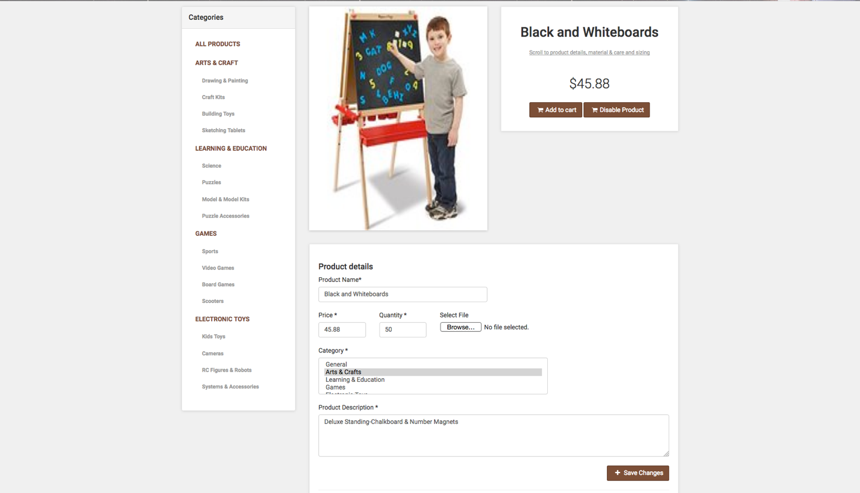

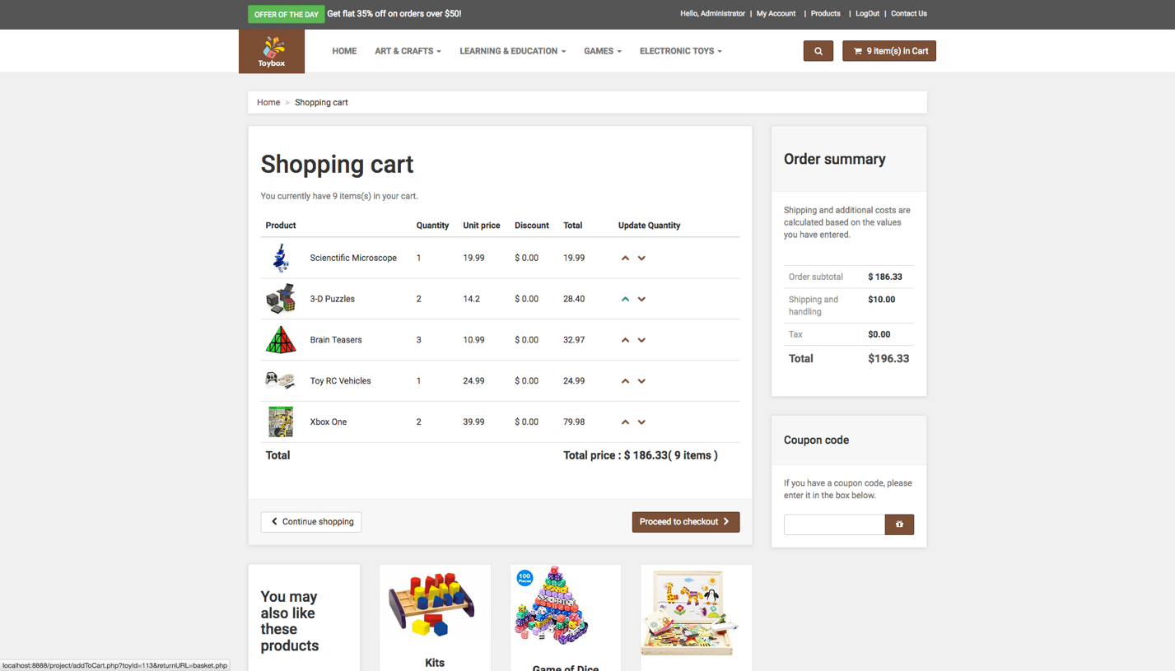

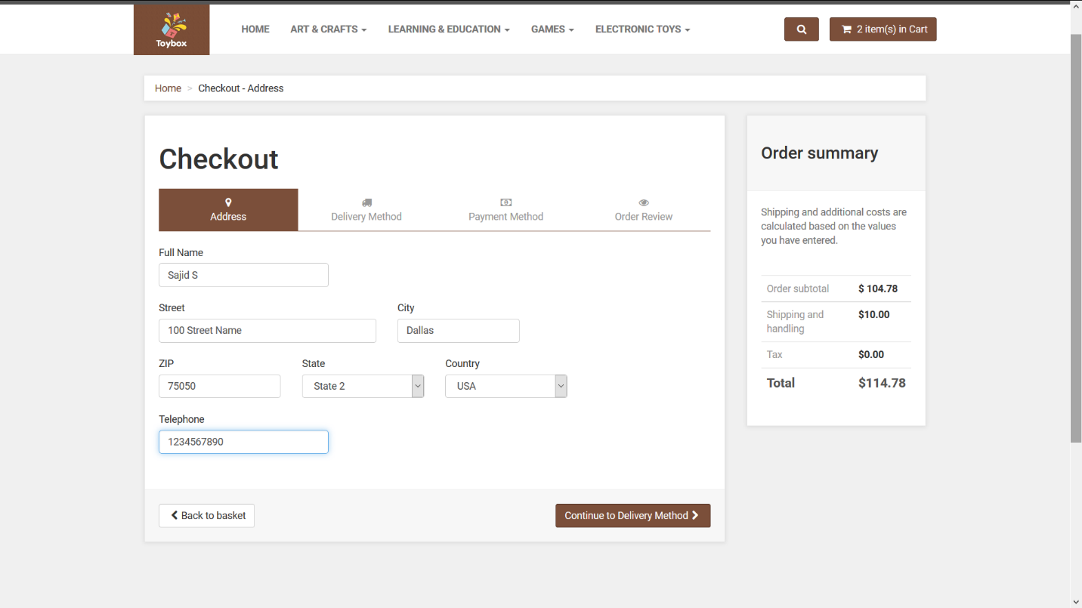

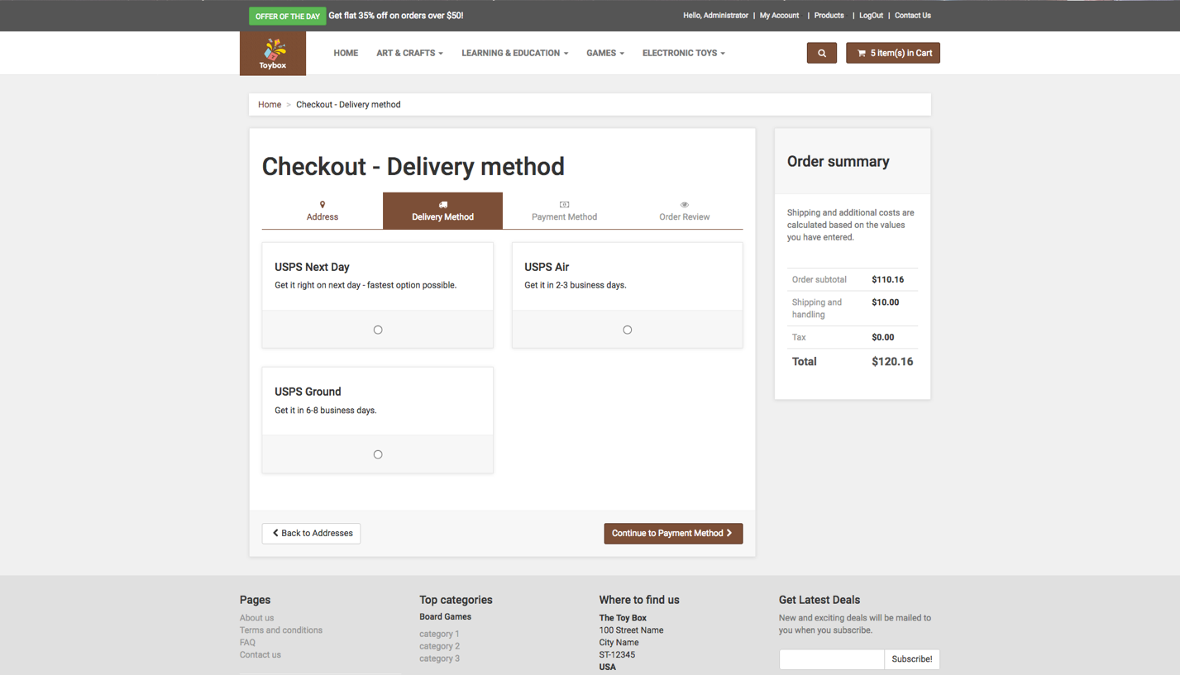

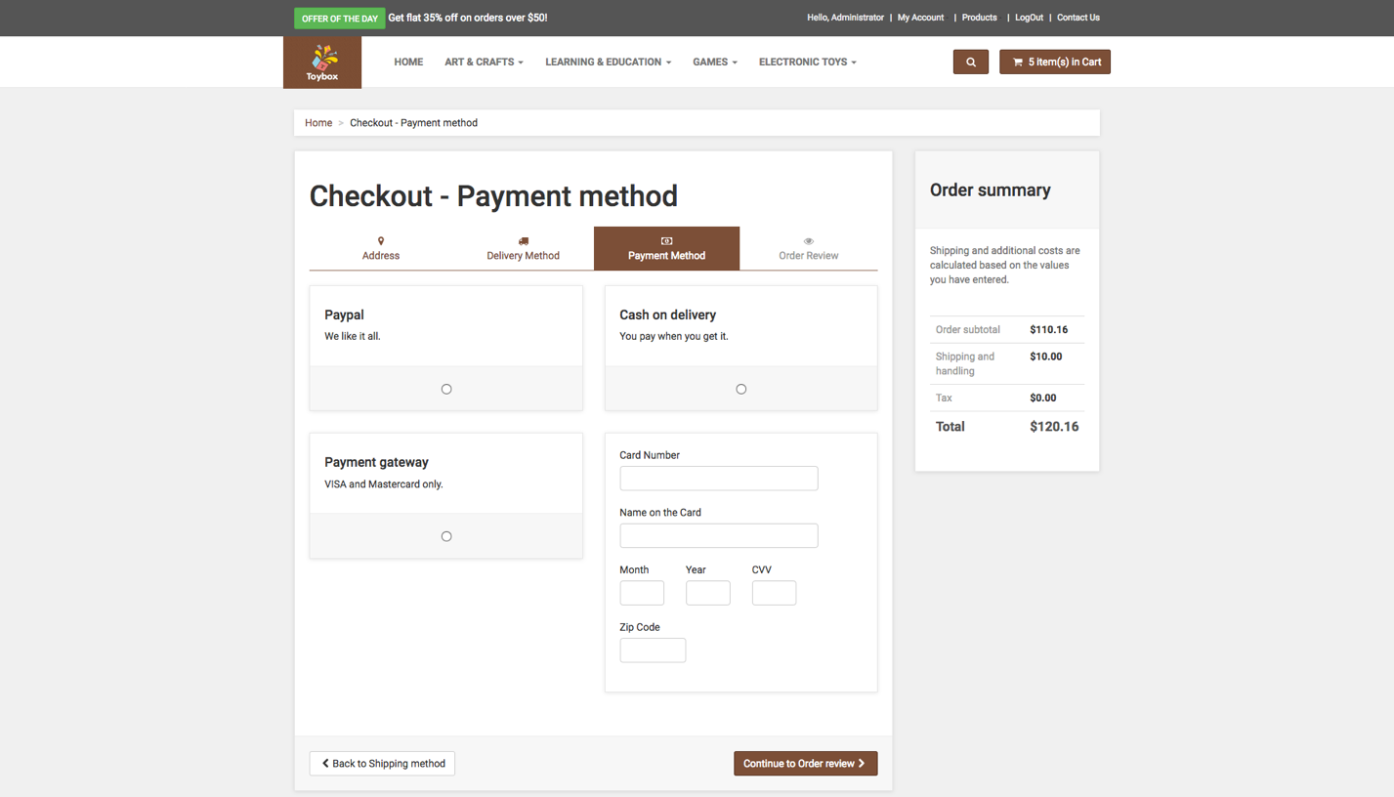

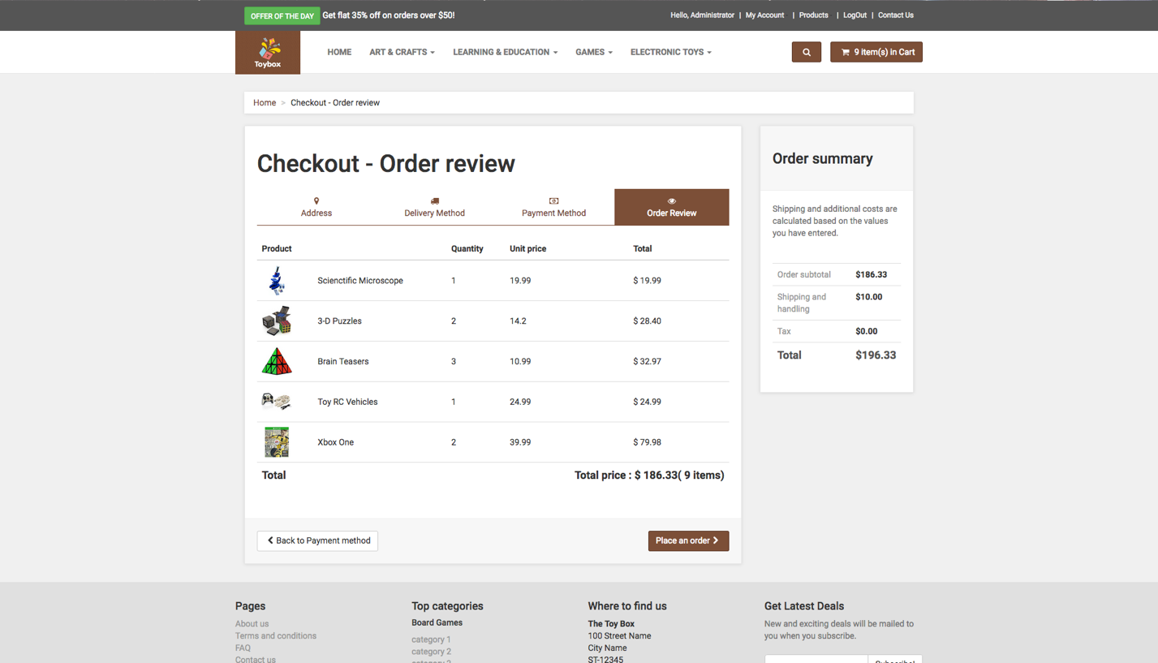

**Note:** As per our discussion with the professor after our project demonstration, the order summary page has been modified along with the database to orders placed and a summary of items that belong to that order.

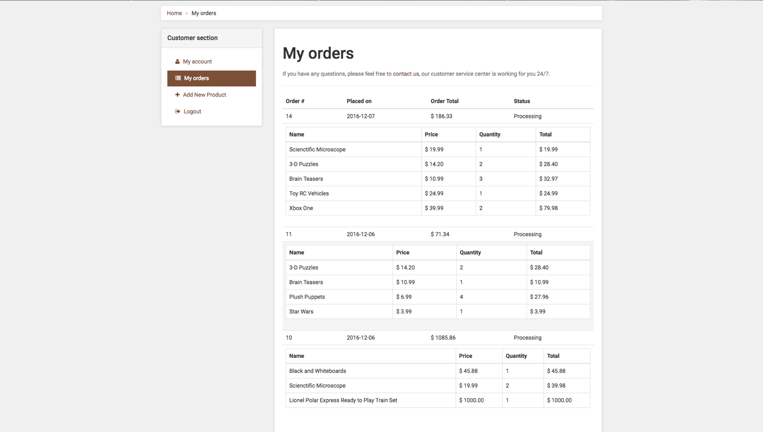

s

# Team Members

* Sajid Siddiqui – SXS140731
* Kunal Tripathi – KXT142730
* Haripriyaa M - HUM160030

# Work Division

* Sajid Siddiqui

Website UI, Order history, Cart functionality: add to cart, remove from cart, Checkout, Related Tables designed and populated.

* Kunal Tripathi – KXT142730

Website UI, Account Management, Validation of users, Search/Sort, Admin Privileges, Related Tables designed and populated

* Haripriyaa M - HUM160030

Product catalog, Product details, Search/Sort, Admin actions, Related Tables designed and populated.